Stock Investing Plan

1. Buy Stocks only in a Market Uptrend. When the IBD changes the outlook from correction or Rally under pressure. Stocks trend for 1 to 3 months, so wait for minor correction/dip, if the market has been up for several months. History shows 3 of 4 stocks simply follow the direction of the general market, either up or down. So Always learn to follow, NOT fight the current trend.
2. Identify stocks that have been pulling back with the market and find support on the rising 50 or 30 day moving average. See either the prices come out of the consolidation with the 3 Arrows breakout signal. Before buying or selling enter the stop price and calculate the position Risk before making the trade.
3. Find stocks with good fundamentals and technical using the IBD CANSLIM criteria or Corporate snapshot.

C = Current quarterly earnings per share(EPS).

Earnings should be strong and accelerating in recent quarters. Look for solid sales growth, a high return on equity and industry-leading profit margins.

A = Annual earnings per share

Took make sure current quarterly growth is not a fluke, also look for strong annual growth over the last 3 years.

N = New company, product/service, industry trend or management.

Focus on companies with something new.

* Composite Rating of 90 or higher
* EPS Rating of 80 or higher
* Accelerating earnings growth
* Average Annual EPS growth 25% or higher or more last 3 years
* Sales growth 25% or higher in most recent quarter
* Return on equity(ROE) of 17% or higher
* SMR (Sales + Margins + Return of Equity) of A or B
* New products or services
* Ranked in top 40-50 of IBD Industry groups

1. Buy stocks being heavily Bought by Institutional Investors.

S = Supply and demand

At key buy points, the best stocks will have above-average increases in volume.

L = Leader or laggard

Focus on the top-rated stocks in the top-ranked industry groups. A stock becomes a true leader by showing strong earnings and innovation.

I = Institutional sponsorship

Look for an increasing number of institutions owning a stock in recent quarters.

* Accumulation/Distribution Rating of A or B
* Relative Strength Rating of 80
* Share price above 15
* Average daily volume of 400,000 or more.

Chart Analysis

* Should be trading above the 30 and 50 week moving average or consolidating around 50 week moving average.
* PLAY was trading above the 30 and 50 weekly moving average but was trading below the 30 and 50 day daily moving average between 7/26 and 9/7/2016. Then it broke below the 50 and 30 day moving averages on the daily chart on Sept 7, and broke out above the daily and weekly moving average on 11/7 on the 3 up arrows method.
* MS had been trading below the 50 and 30 day and week moving averages for earlier part of 2016. Starting in March it started moving above the 30 and 50 daily moving averages but did not make a sustained move till it conclusively broke above the 30 week average in July 11 or 12th.
* Prices shall move between the support and resistance areas. Once the support broken it becomes resistance and once resistance broken it should become support.

Support and Resistance will be formed by

* Gaps or Window
* Middle of a long candle
* Top/Bottom of the long candle
* Joining at least 2 prior highs or lows
* Moving averages

An upward bounce occurs in a series of bars at support. This is often referred to by Investools® instructors as a **CAHOLD**, or a **C**lose **A**bove the **H**igh **O**f the **L**ow **D**ay. The pattern first identifies the candle with the lowest price in the series—this is the low day. Then, when a candle has a closing price above the high of the low day, it completes the pattern. When investors see this pattern, it gives them confidence that price has made and bounced off of a new support level.

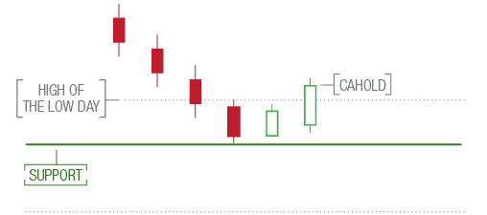

A **downward bounce** is similar, except it occurs at resistance. It’s referred to as a **CBLOHD**, or a **C**lose **B**elow the **L**ow **O**f the **H**igh **D**ay. This pattern identifies the candle with the highest price in the series—this is the high day. Then, when a candle has a closing price below the low of the high day, it completes the pattern. When investors see this pattern, it gives them confidence that price has made a new resistance level.

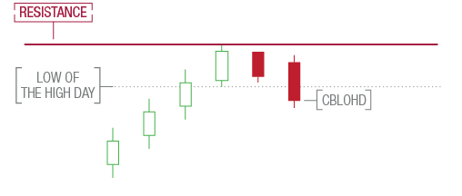

Application of CAHOLD with Gaps: Just -

